Jack Kapino

Homework 3

Cs 253

**Problem 2:**

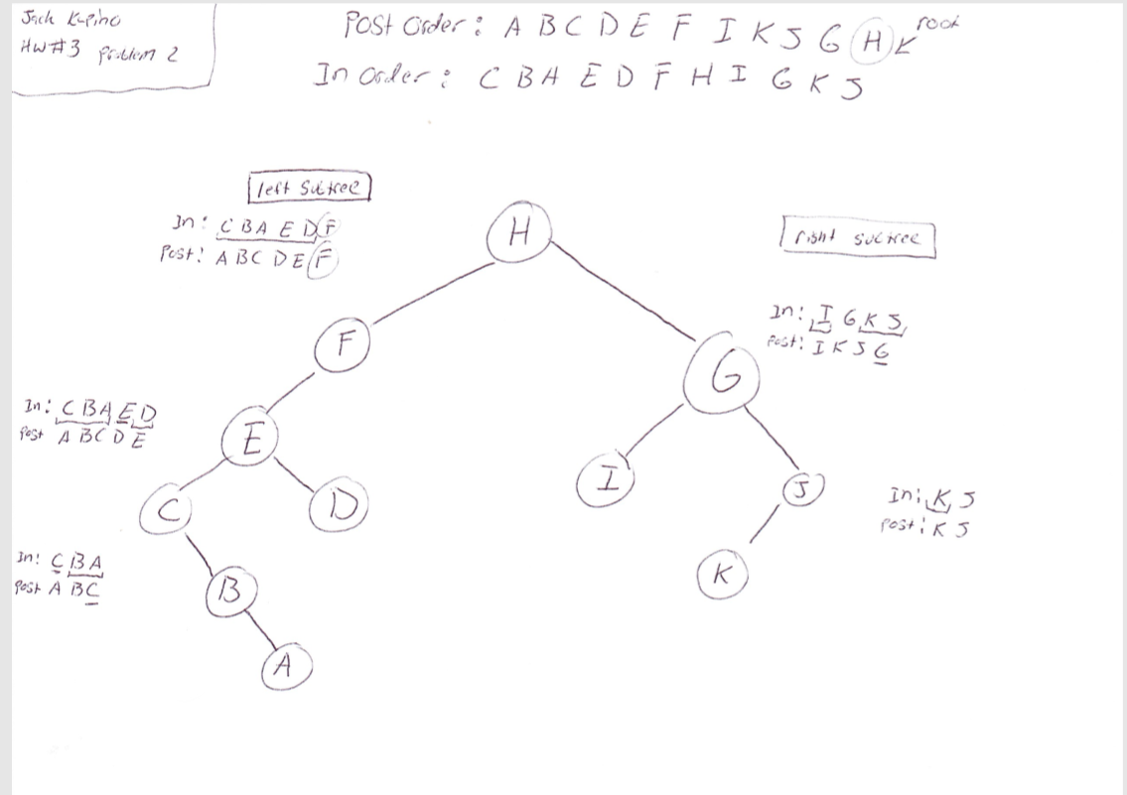

When drawing a binary tree from the given Inorder and Postorder traversals, you must first start by determining the root of the original binary tree. This is done by locating the last element in the post order traversal. In problem 2 the last element in the Postorder is “H” which will be the root node. Once you have determined the root node, you must locate the root element in the Inorder traversal. This implies all elements to the left of the root node will be part of the left subtree. All the elements to the right of the root node “H” will be elements of the right subtree. This process can be done recursively for both left and right subtrees until all elements of both left and right subtrees are in the correct position. For example drawing the right subtree of problem 2, will require you to take elements that have been identified as the right subtree and repeat the same process. First Find the last element of right subtree located in the Postorder traversal “G”. This will be the root Node of the right subtree. Next take this element find its location in the in order traversal,and create another subtree that is inside the original right subtree. All elements to the left of the right subtrees root will be left children and elements to the right of that root will be right children. The process is recursively called again finding the next subtree root , which will be “J” and determining whether or not the remaining elements are left or right children of the particular subtree.

